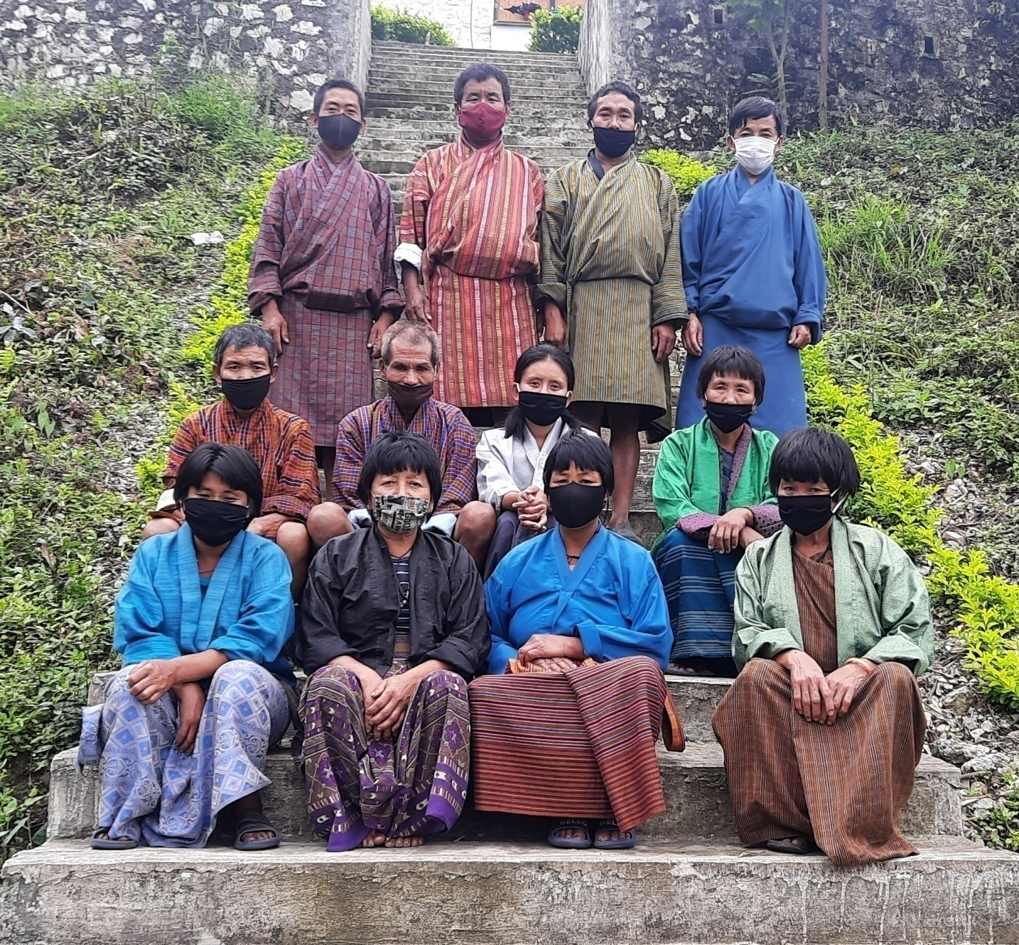
CHIMONG GONGPHEL SHINGMEN THOENKEY DETSHEN MANAGEMENT PLAN
(PLAN PERIOD: 2021-2026)
Contents
Executive Summary 4
Introduction 5
PART 1: BACKGROUND INFORMATION 6
1.1: Rubia (Rubia Cordifolia) 6
1.2: Yongjiba (Pouzolzia sp.) 6
1.3: Pipla (Piper Pedicillatum) 7
1.4: Tsakusha (Thysanolaena latifolia) 8
PART 2: NWFPS MANAGEMENT AND MARKETING PLAN 8
2.1: Management Objectives 8
2.2: NWFPs descriptions 9
2.3: NWFP Prescriptions for sustainable harvesting 11
2.4: Marketing and sales plan 12
2.5: Marketing arrangements 12
2.6: Benefits to the members 12
2.7: Benefits to the group 13
PART 3: BY-LAWS-GROUP REGULATIONS AND NORMS 13
3.1: Responsibilities and rights of members: 13
3.1.1: New membership 13
3.1.2: Withdrawal from the group 14
3.2: Executive committee 14
3.3 Terms of References of committee members 14
3.3.1: Chairperson 14
Responsibilities of Coordinator/ Chairperson: 14
3.3.2: Secretary 14
Responsibilities of Secretary: 14
3.3.3: Treasurer 15
Responsibilities of Treasurer: 15
3.4: Compensation to the committee members 15
3.5: Membership fee and purpose 15
3.6: Community development fund and utilization 15
3.7: Conflict resolution 15
3.8: Penalties 16

List of figures
Figure 1: Rubia cordifolia (source:Internet) 6
Figure 2: Pouzolzia sp. (source: Internet) 7
Figure 3: Piper pedicillatum (source:Internet) 7
Figure 4: Tsakusha (source:Internet) 8
Figure5; Collection area map 10
Figure 6: Collection areas 10

List of tables
Table 1: Block description of individual NWFPs species 9
Table 2: Marketing and sales plan of NWFPs 12

Executive Summary
Chimong Gongphel Shingmen Thoenkey Detshen was formed in 2013 by the interested households of Chimong village. The primary objectives were to harvesting of Non-wood forest Products (NWFP) sustainably and also to generate income through sale of harvested NWFPs.
The group has identified 4 potential NWFPs namely, Rubia cordifolia (Laniru), Piper pedicillatum (Pipla), Pouzolzia sp. (Yongjiba) and Thysanolaena latifolia (Tsakusha). Of these 4 species, Rubia cordifolia has been harvested most followed by Pouzolzia sp., Piper pedicillatum and Thysanolaena latifolia.
The management group performance till date was up to the mark. A mere 17 households of the group managed to produce certain amount of NWFP every year and generated income which helped to enhance the rural livelihood. Till date, minimal amount of revenue generated has been contributed to the group joint account. Thus, almost a decade after group formation has resulted to a less than Nu. 100000/- in their joint account.
The group though small, is also facing certain challenges. Since there are fewer educated members in the group coupled with no incentives to the executive committee members, there are no members willing to take the role of executives. Other challenge is in marketing after the harvest of the NWFPs. Since there are very few certified NWFP dealers/buyers, the group has to sell the products at dealers’ rate which is not that lucrative. However, the group members are hopeful with the new system of auctioning which will somehow help in up-scaling the price.

Introduction
Chimong Gewog under Pema Gatshel Dzongkhag is one of the remote Gewogs with just around 200 households. The people mainly depend on farming for their livelihood. The Gewog has an elevation ranging from approximately 500-2800 masl. It has a diverse vegetation distribution of Warm-broad leaved forest in the south and Cool broadleaved forest in the north with patches of Chir Pine Forest in between. Considering the wide range of elevation and diverse climatic conditions and vegetation cover, the area harbors various Non-wood Forest Products (NWFP) which enhance their livelihood through the sale of these NWFP species.
Chimong Gongphel Shingmen Thoenkey Detshen was initially formed in 2013 by a total of 23 households of Chimong Village. However, due to personal reasons and other circumstances, the number of household kept on fluctuating over the progressing year. Now, the group has 16 confirmed members.
The group has 4 primary NWFP species namely, Rubia cordifolia, Piper pedicillatum, Pouzolzia sp. and Thysanolaena latifolia which the group will harvest based on harvesting prescription of the individual species. As per the management plan, the group will harvest the mentioned NWFP species on sustainable basis and also generate income at the same time. A total of around 300 hectares will be managed by the group and this management plan will serve for another 5 years.

PART 1: BACKGROUND INFORMATION

1.1: Rubia (Rubia Cordifolia)
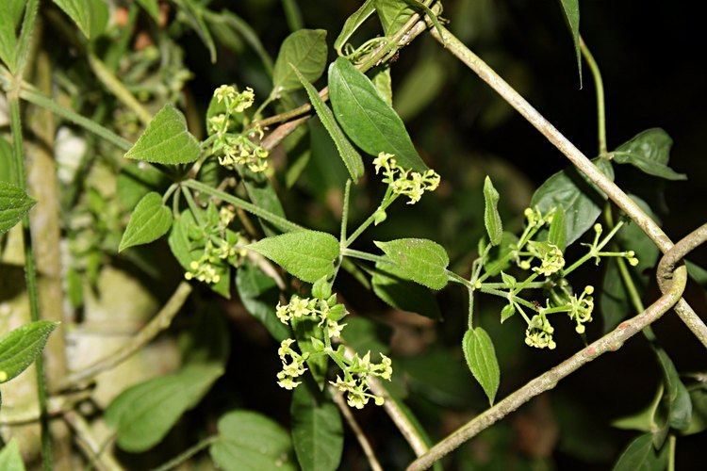
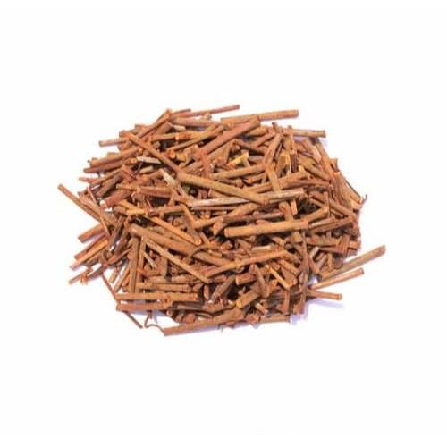
Rubia, locally known as Laniru in eastern Bhutan is a perennial herbaceous climbing under Rubiaceae family. It has a very long cylindrical roots with thin red bark. Stem is long, rough, slightly woody at the base, quadrangular, and glabrous. Branches climb by a means of numerous prickles. It flowers usually from June to August. It grows along the disturbed forest land such as forest edge and clearings.
  - Figure 1: Rubia cordifolia (source:Internet)
Uses: The plant, particularly the root has a medicinal value used especially in traditional Tibetan and Ayurvedic medicine. The wider use is in extraction of red pigment for textile dying. Locally it’s also use to heal body ache by applying the crushed leaves over it. The plant is also use to clean and color the planked floor in rural houses.

1.2: Yongjiba (Pouzolzia sp.)
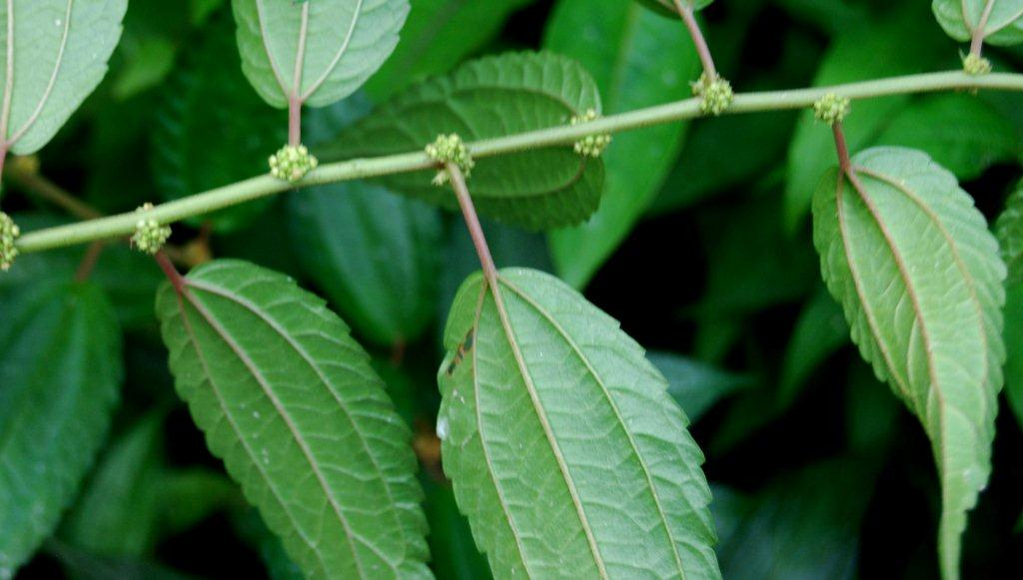
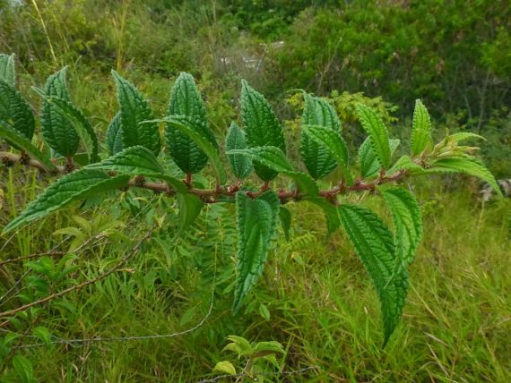
Pouzolzia is an evergreen shrub that grows in warm broad leaved forests, thickets and edges of woods, and in the patches of abandoned cultivation.
  - Figure 2: Pouzolzia sp. (source: Internet)
Uses: It is used as an important raw-material in incense manufacturing process as an adhesive to bind ingredients. It also has medicinal values, but not widely used at local level.

1.3: Pipla (Piper Pedicillatum)
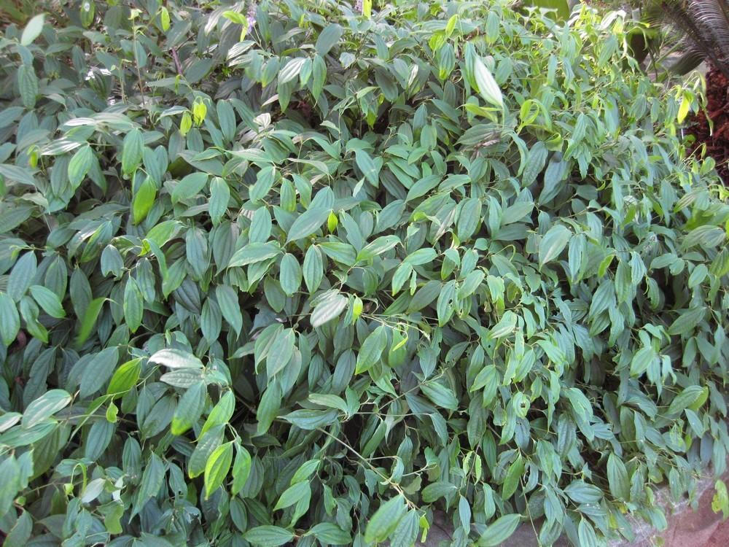
It is a perennial bush plant under the family Piperaceae. It has oval leaves and tail-shaped inflorescence covered with tiny flowers. It is usually found in warm-broadleaved forests as an undergrowth.
  - Figure 3: Piper pedicillatum (source:Internet)
Uses: Parts of the plant (particularly fruits) are used in the field of medicine and also in culinary as spice-mix.

1.4: Tsakusha (Thysanolaena latifolia)
It is a plant under Grass family (tribe: Thysanolaeneae). It is widely distributed in many parts of the country.
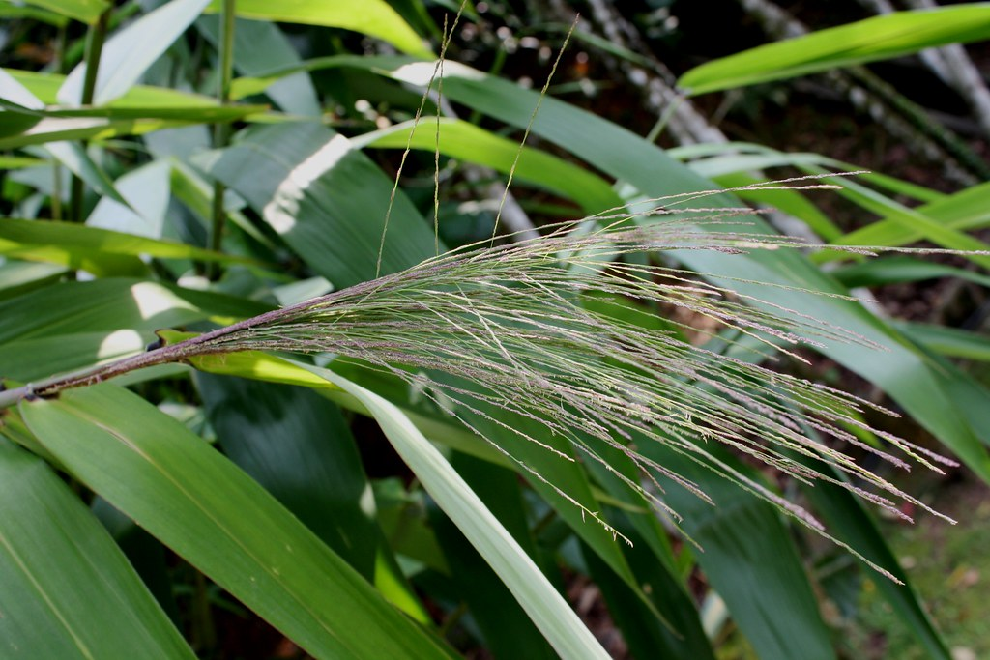
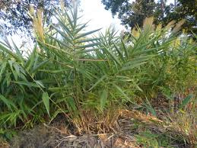

  - Figure 4: Tsakusha (source:Internet)

Uses: The flowers of the plant are used as cleaning tool/as broom

PART 2: NWFPS MANAGEMENT AND MARKETING PLAN

2.1: Management Objectives
- To generate income through sale of NWFPs.
- To manage the NWFP sustainably at local level through community participations.

2.2: NWFPs descriptions

Table 1: Block description of individual NWFPs species
NWFP name | Collection area (name) | Estimated areas (acres) | Parts harvested | Use purpose (traditional and others) | Harvesting season (months) | Estimated quantity that can be collected (Kg)
Laniru (Rubiacordifolia) | Baizuborang | 20 | Stem | Dye | November-February | 1500 kg
 | Songsongri | 10
 | Marto | 10
Yongjuba (Pouzolzia sanguine) | Baizuborang | 20 | Bark | Adhesive for incense | August-February | 1500 kg
 | Songsongri | 10
 | Marto | 10
 | Yongkaijaab | 30
Pipla (Piper Pedicillatum) | Drangmey chhu area | 40 | Fruit | Spice/ medicine | September onwards | 100kg
 | Ritsong | 10
Tsakusha (Thysanolaena latifolia) | Tangsharang | 10 | Inflorescence | Soft broom Fodder | December- March | 200 Bundles

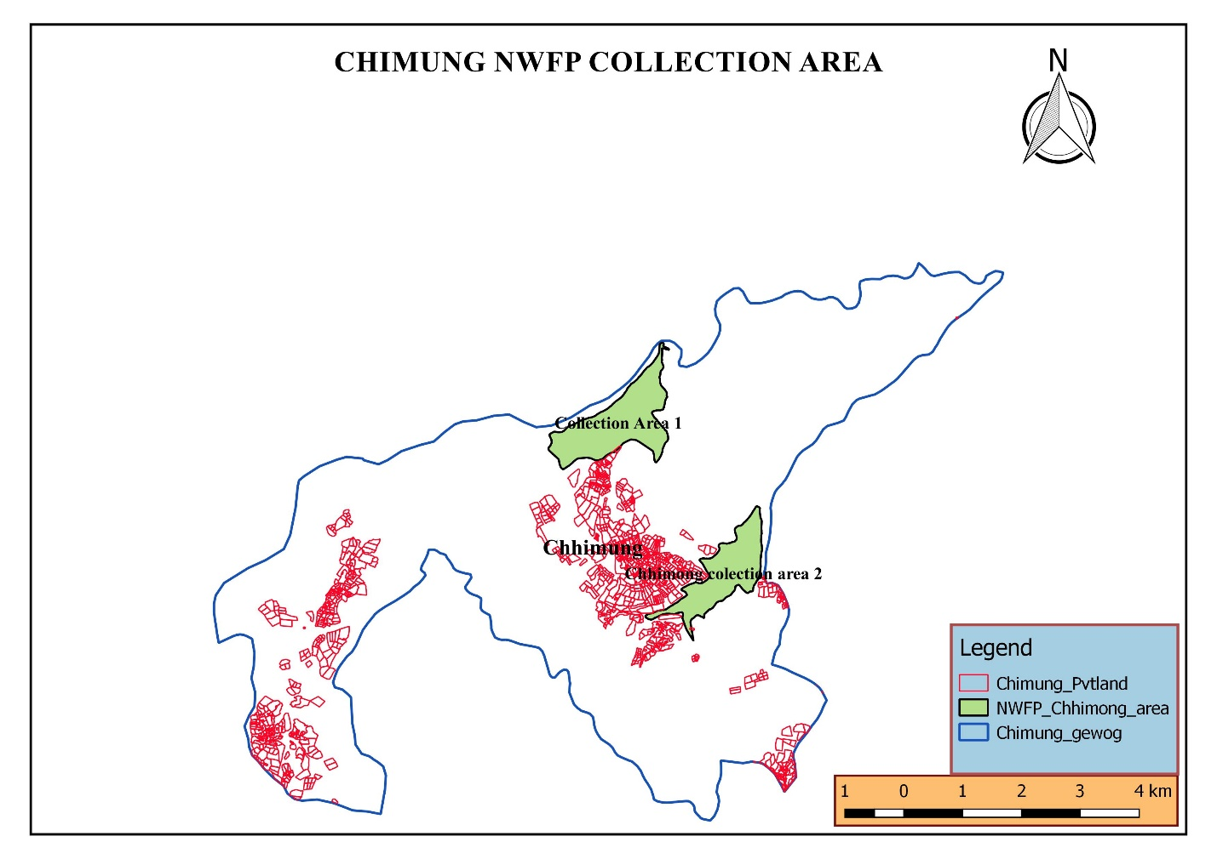
  - Figure5; Collection area map
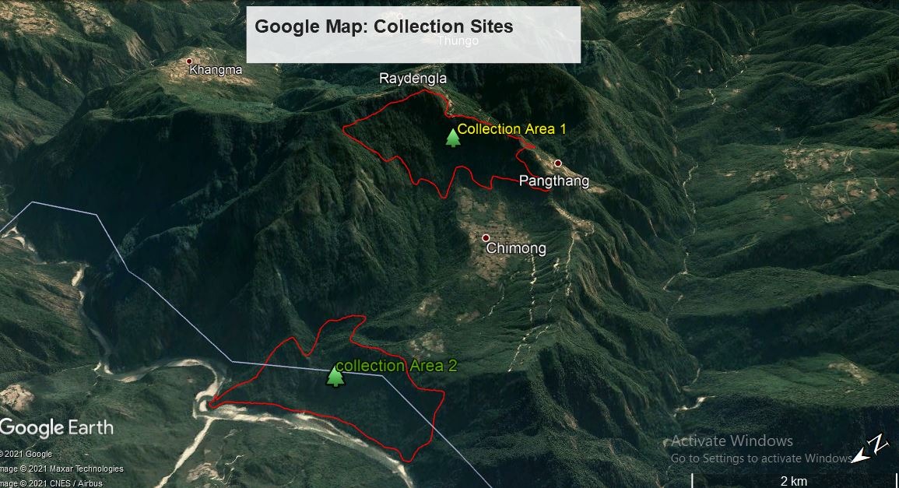
  - Figure 6: Collection areas

2.3: NWFP Prescriptions for sustainable harvesting
NWFP species | Harvesting prescriptions for sustainable harvesting
Laniru  (Rubia cordifolia) | -Use sharp scissors for the collection of the upper part of the plant.  -Cut the plant at 5 cm above ground level.  -Leave at least 10% of the plants without collecting or harvesting any raw materials from them (these plants shall act as seed plants for natural regeneration).  -Do not collect roots.  -Do not uproot entire plants
Yongjiba  (Pouzolzia sanguine) | -Cut the plant at 10 cm above the ground level (the left stump will coppice in the following growing season).  -Do not damage the remaining young stands/ seedlings/ saplings  -Felling of surrounding trees to ease harvesting is prohibited.  -Leave at least 10% of the plants to allow natural regeneration.  -Collection of roots is strictly prohibited for ecological reasons
Pipla  (Piper pedicillatum) | -Collect fruits only when matured  -Harvest fruits only after the announcing the date of harvest either by coordinator or by forest personnel  -Harvest only the fruits by hand picking without damaging, cutting or uprooting the entire plant.
Tsakusha (Thysanolaena latifolia) | -Cut the foliage, inflorescence at 15 cm from the ground  -Do not damage the rhizome in order to allow natural regeneration

2.4: Marketing and sales plan

Table 2: Marketing and sales plan of NWFPs
NWFP name | Potential market | Estimated quantity for sale per season | Expected price per unit | Total Nu.
Laniru  (Rubia cordifolia) | Local traders, Indian market | 1500 kg | 65.00 | 97500.00
Yongjiba  (Pouzolzia sanguine | Local trader, incense making factory and Indian market | 1500 kg | 65.00 | 97500.00
Pipla  (Piper pedicillatum) | Local traders | 100 kg | 150.00 | 15000.00
Tsakusha (Thysanolaena latifolia) | Local shopkeepers and institutions | 200 bundles | 25.00 | 5000.00

2.5: Marketing arrangements
The group members will collect the NWFPs individually during the harvesting period and store properly at their home. The members will segregate products as per the standards required by the trader. The committee members will inform individual members to bring the NWFPs to the group store house. The committee will then inform the NWFP Auction Strategy Committee members for auctioning of the products. Auction will be organized in the presence of Chairperson from the respective NWFPs groups as a representative of the group.
The committee members may deduct the expenditure such as transportation, community fund and compensation before making payment to the group. The sharing of income to the individual group member will be done based on the quantity of NWFPs collected by the respective members after deduction of all necessary expenditure incurred till the sale of products to the traders.

2.6: Benefits to the members
The individual members have the right to collect NWFPs based on harvesting prescription as reflected in the management plan during the harvesting period. Based on the quantity of NWFPs harvested, individual will get 90% from the total revenue generated by individual after deducting all the expenses.

2.7: Benefits to the group
Every year, the members will contribute Nu. 100 as membership fees to the group joint account. Individual members will also contribute 10% of the total revenue generated from the sale of NWFPs for the welfare of the group.

PART 3: BY-LAWS-GROUP REGULATIONS AND NORMS

3.1: Responsibilities and rights of members:
- Every group member will have equal right to harvest and sale the NWFPs from the designated area.
- Every member will harvest the NWFPs based on management prescriptions as reflected in the management plan.
- The individual member will not collect and harvest on their own, but rather after the coordinator/concerned forest office announce the date for collection.
- The group members sell their products through the group and not individually as and when they wish to.
- Every member of the group will have equal right and responsibility to report to the committee members for violation of the management rules/By-Laws.

3.1.1: New membership
- A new member will be allowed to join the group only after he/she pays a compensation equivalent to the amount the existing members have contributed to the total community fund.

3.1.2: Withdrawal from the group
- If a member withdraws from the group due to loss of interest, he/she will not get any benefit from the group. However, if he/she withdraws due to genuine/unavoidable circumstances, he/she will be rewarded 50% of his/her share from the total fund accumulated during his/her tenure.

3.2: Executive committee
Sl. No | Name | Designation | contact Number | Remarks
1 | Norbu Chogyal | Chairperson
2 | Leki Wangdi | Secretary
3 | Karchung | Treasurer
4

3.3 Terms of References of committee members

3.3.1: Chairperson
Responsibilities of Coordinator/ Chairperson:
- To chair all kinds of meeting relating to NWFPs management matter.
- To resolve the disputes and conflict among the members.
- To enforce the fine and penalty.
- To explore market for the sale of NWFPs and keep contact with the traders.
- Fix date of collection and make announcement to the group members in consultation with the Dzongkhag Auction Strategy Committee members.

3.3.2: Secretary

Responsibilities of Secretary:
- Provide assistance to the Chairman.
- Officiate Chairperson during his/her absence.
- Maintain records of the activities implemented, and also minutes of meeting.
- Write official correspondence.
- Compile the progress report and submit to the concerned forest officer annually for further submission to the Division.

3.3.3: Treasurer

Responsibilities of Treasurer:
- Officiate the Chairperson or Secretary in their absence.
- To keep/maintain all the financial records and present the details funds to Committee and the group members during the meetings.
- Collection of annual membership fee from the group members.
- Taking care of financial arrangements in the group.

3.4: Compensation to the committee members
- The executive committee members will not be compensated/rewarded financially as the group fund is not that huge as of now.

3.5: Membership fee and purpose
- Every year, Nu. 100/- will be collected from every member as membership fee.
- The collected fee will be deposited in the joint account as a Community Development Fund (CDF) that will be used for pre-financing marketing purposes and other expenses for the welfare of the group.

3.6: Community development fund and utilization
- The bank account will be operated by Chairman, Secretary and Treasurer, and they are signatory authority of the Bank Account. All sale and expenses done by the Chairman, Secretary and Treasurer should be in the notice of members.
- All expenditure incurred on behalf of the group will be born from the Joint Account. Technical support will be sought from the concerned Gewog ROs.
- The source of fund will be from fine imposition, membership fees and the selling of NWFP.
- The fund accumulated will be shared among the group members to certain percentage of the total accumulation once the bank account become enough to rotate. Total fund will be not kept below 100000/- as security fund for emergency purpose.

3.7: Conflict resolution
- If conflicts between the NWFP Group and outsiders arise, the executive committee will inform the concern Gewog Forestry Incharge. The case shall be forwarded to the Headquarter Range for case settlement or to further forward to the Division if the case severe.
- The conflict arising among the group members regarding NWFP matters will resort firstly to the Chairman. If the nature of the conflict is unable to resolve by the Chairman, the case will be forwarded to the Gewog RO for further settlement. Similarly the case will be forwarded to the Headqaurter Range/Division depending on the severity of the case/issue.

3.8: Penalties
- If any non member collects any NWFP from the designated area, he/she will be fined Nu. 1500/- and also reported to the Forest Office for further action as per the existing Forest Rules and Regulations. The products harvested will also be seized.
- In case if the member of the NWFP Group violates the harvesting rules as set in this plan, he or she will not be allowed to harvest the NWFP for the rest of the season and the next season.
- Members collecting the NWFP prior to the fixed date/announcement made by the Coordinator/ RO, the product will be seized by the group and also fined Nu. 1000/- per occasion.
- Those members who could not collect it owing to old age or death or other genuine reasons will be considered.
- Only one member from each household will be entertained and the quantity collected by additional will be surrendered to the group.
- An absentee during meeting is liable to pay Nu. 300/- per head per occasion.
- If a member fail to pay membership fees or fails to attend meeting and also to pay the fine for three consecutive occasions, he/she will be terminated from the group without any benefits.
- An absentee owing to death, sick or other genuine reasons are considered only after the approval from Chairperson.

ANNEXURES: Membership list
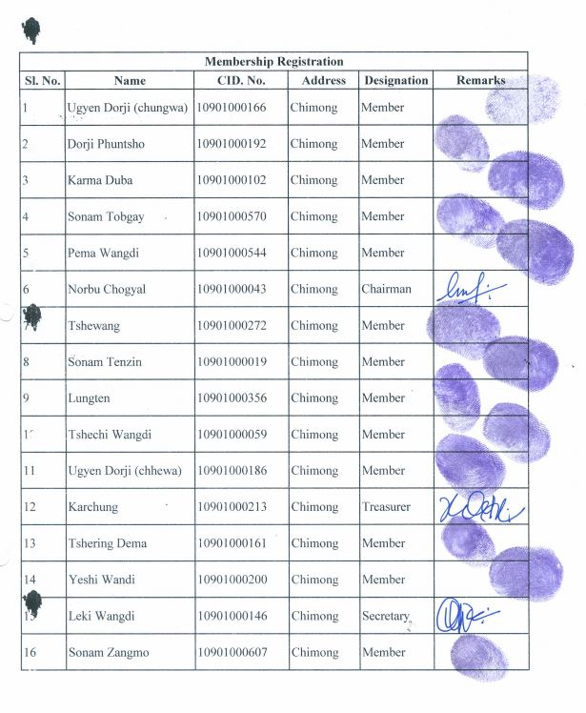
Past collection record 2018-2021
Collection/Harvesting for last 3 years
Sl No. |  | Name of Group | Dzongkhag | Geog | Village | No. of HHs | Species | Qty Collected | Qty sold | Rate/Unit | Amount | Remarks | challenges/issues
1 | 2019 | Chimong NWFP Group | Pema Gatshel | Chimong | Chimong | 17 | Piper sp. | 50 kg |  |  |  | Not sold
 |  |  |  |  |  |  | Poulzozia sp. | 300 kg
2 | 2020 |  |  |  |  |  |  |  |  |  |  | Not collected/harvested
3 | 2021 |  |  |  |  |  |  |  |  |  |  | Not collected/harvested

